**Lab 1: Setting up Apache Server, Configuring Firewall with iptables, and Checking Logs**

**Name:** Zhalgas Bagytzhan  
**Date of Submission:** 17.03.2025  
**Class Date and Time:** Thursday, 15:00-18:00

**Step 1: Start and Configure Security Workstation as a Web Server**

**1.1 Start the VM**

* Launched Security Workstation VM in VirtualBox.
* Logged in with appropriate credentials.

**1.2 Install Apache Server**

* Opened a terminal and updated package lists:

sudo apt update

* Installed Apache server:

sudo apt install apache2 -y

* Started the Apache service:

sudo systemctl start apache2

* Enabled Apache to start automatically after reboot:

sudo systemctl enable apache2

**1.3 Verify Apache Installation**

* Checked if Apache is running:

sudo systemctl status apache2

* **Expected Outcome:** Apache service should be active and running.

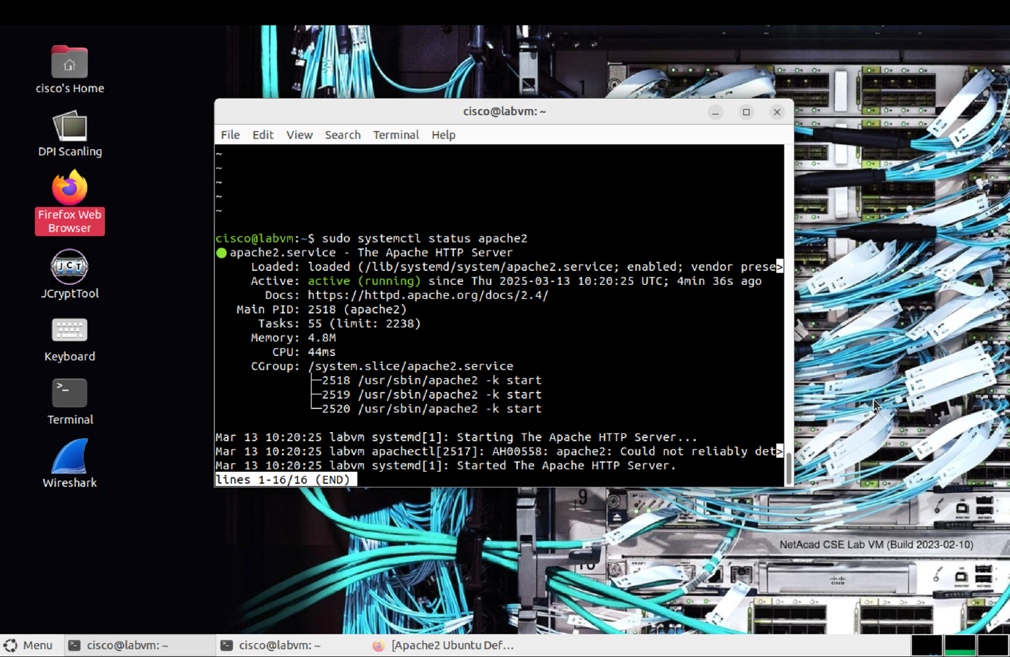

**1.4 Get the Server IP Address**

* Ran the following command to get the IP address:
* ip addr show
* **Expected Outcome:** IP address displayed under eth0 or ens33.

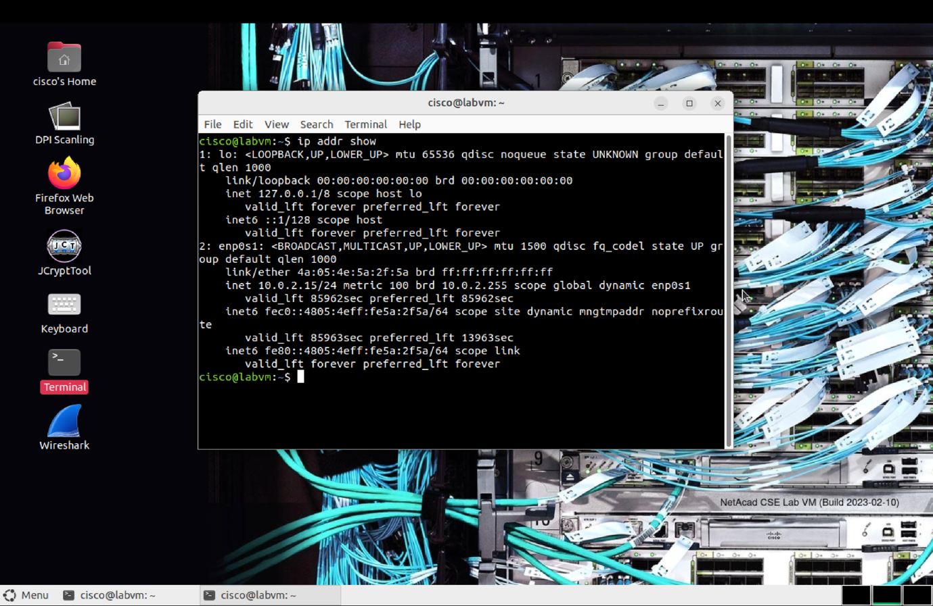

**Step 2: Access Apache Web Server from Host Device**

* Opened a browser on the host device.
* Entered the VM’s IP address in the browser:

http://127.0.0.1

* **Expected Outcome:** Default Apache2 Ubuntu page displayed.

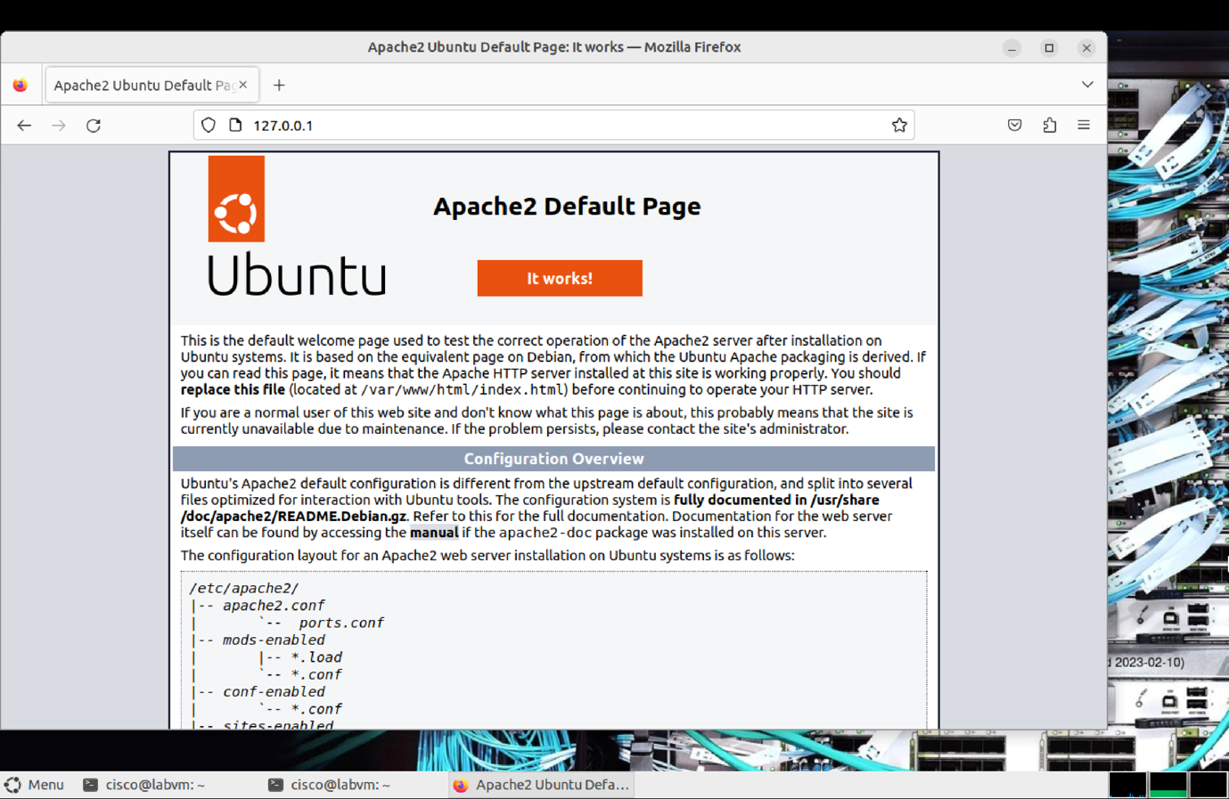

**Step 3: Configure Firewall with iptables**

**3.1 Block HTTP (Port 80) Access**

* Ran the following command to block port 80:

sudo iptables -I INPUT 1 -p tcp --destination-port 80 -j DROP

**3.2 Verify the Firewall Rule**

* Listed iptables rules:

sudo iptables -S

* **Expected Outcome:** Rule to drop traffic to port 80 should be listed.

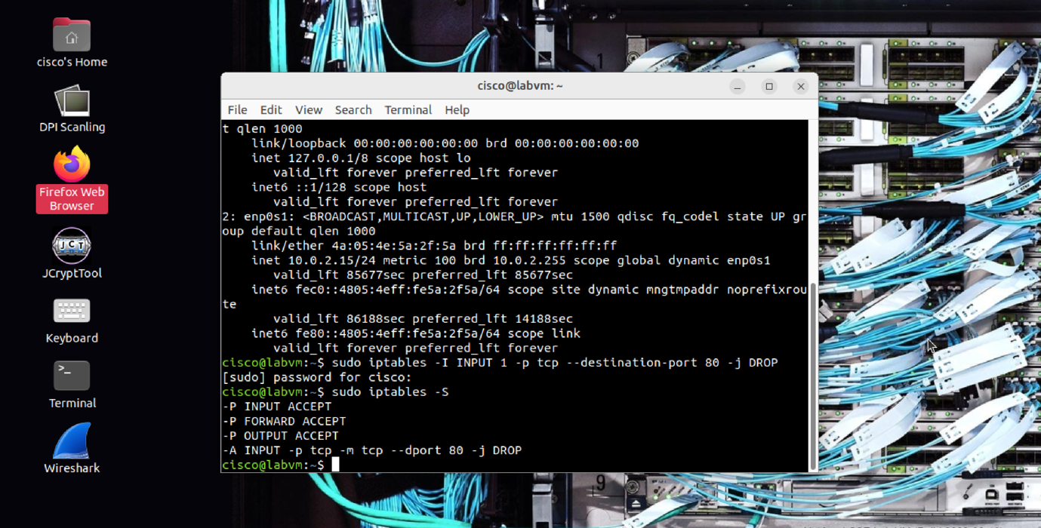

**3.3 Test HTTP Access**

* Attempted to access Apache page from the host browser:

http://127.0.0.1

* **Expected Outcome:** Connection failed.

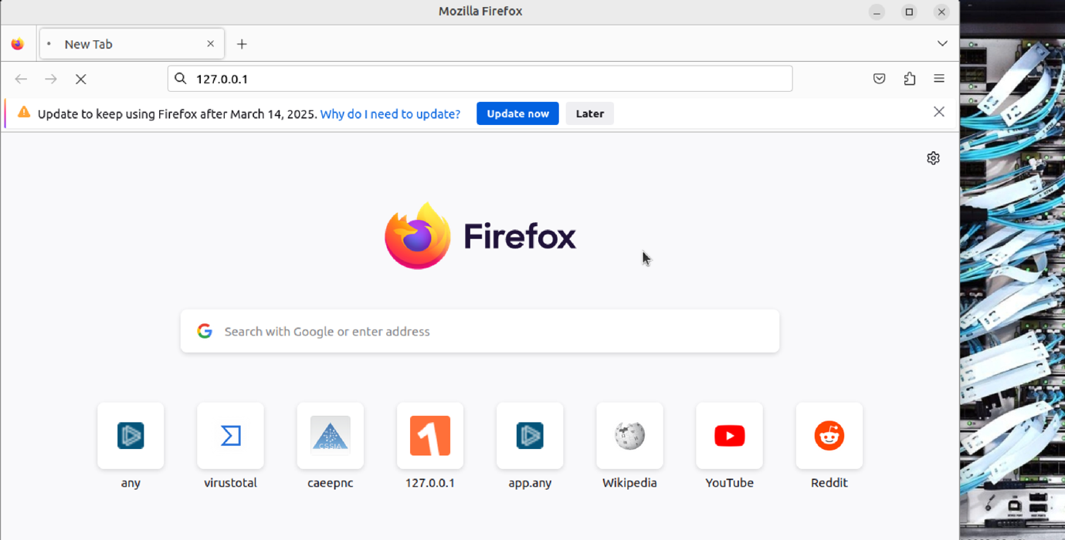

**Step 4: Re-enable HTTP Access and Set Up Logging**

**4.1 Allow HTTP (Port 80) Again**

* Inserted a rule to allow incoming connections:

sudo iptables -I INPUT 1 -p tcp --destination-port 80 -j ACCEPT

**4.2 Enable Logging**

* Added a logging rule:

sudo iptables -I INPUT 1 -j LOG

**4.3 Check the Firewall Rules**

* Verified rules:

sudo iptables -S

* **Expected Outcome:** ACCEPT and LOG rules should be above DROP rule.

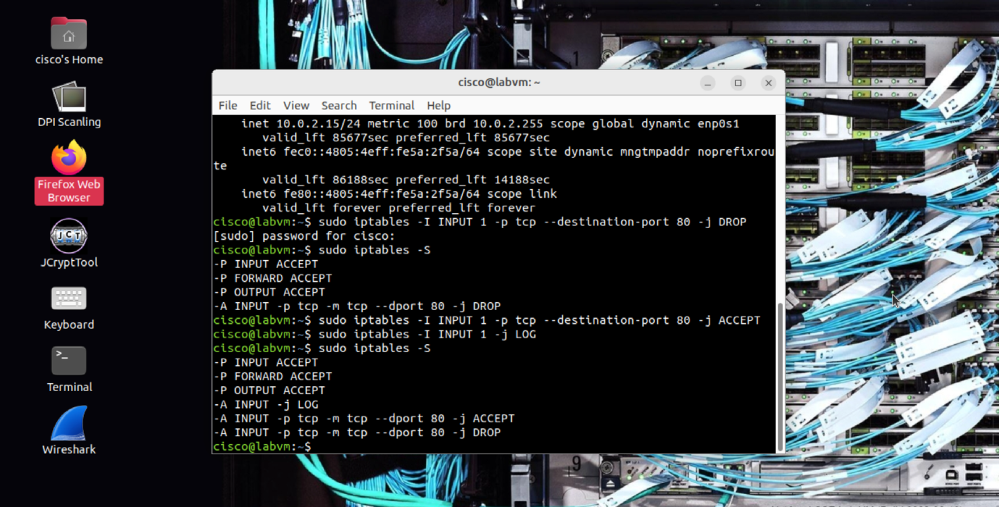

**4.4 Verify HTTP Access**

* Opened browser and accessed Apache page again.
* **Expected Outcome:** Page should load successfully.

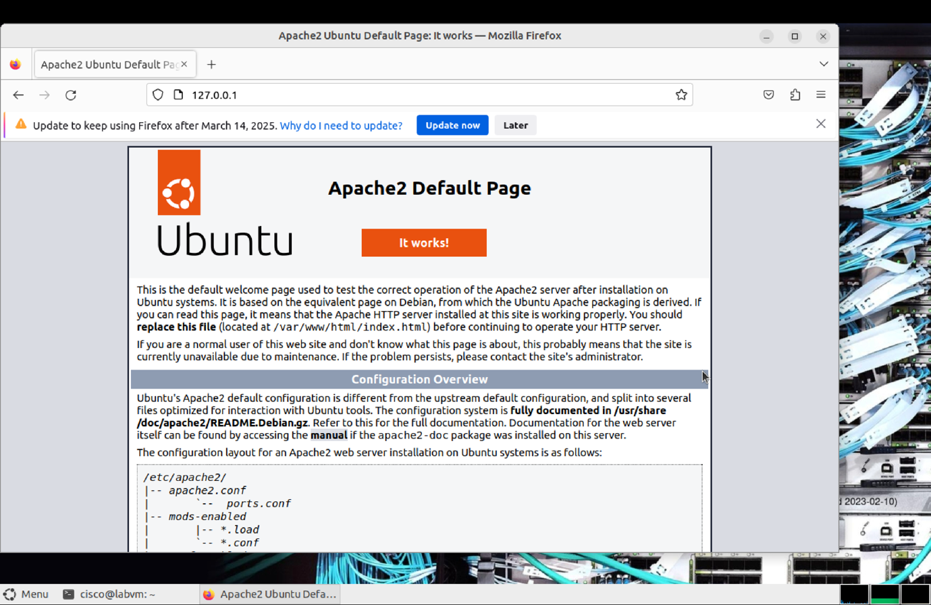

**Step 5: View iptables Logs**

**5.1 View Log Entries**

* Displayed log entries related to port 80 traffic:

sudo tail /var/log/kern.log | grep "80"

**5.2 Analyze the Logs**

* Reviewed logs for incoming connection attempts.
* **Expected Outcome:** Log entries should show attempts to access port 80.

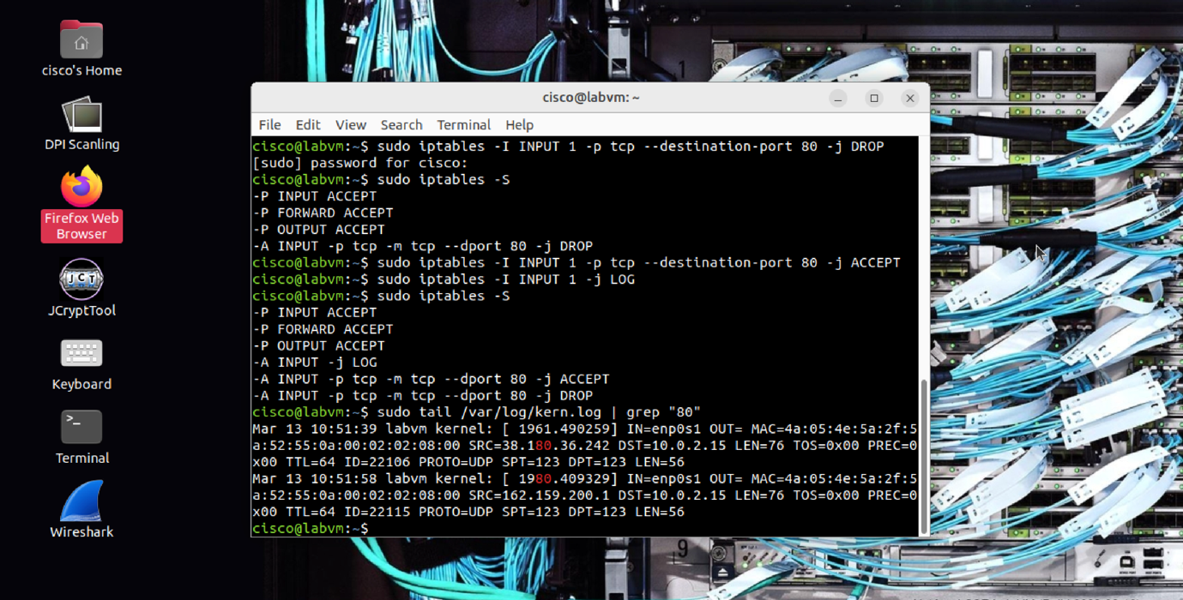

**Conclusion**

In this lab, we successfully installed and configured an Apache web server, managed HTTP traffic using iptables, and set up logging to monitor connection attempts. Testing through a web browser confirmed the firewall changes. The lab demonstrated the importance of firewall rules in controlling network access and securing server environments.